S. No | Name | Qualifications | Designation
1. | 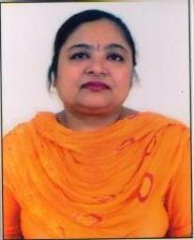 | Dr. Parineeta Singal  M.A.(Geography) M.Ed., UGC, Ph. D (Edu.) | Principal
2. | 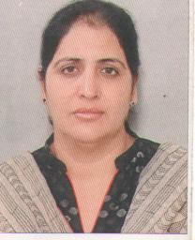 | Dr.Parmjit Kaur  M.A.(Pol. Sci.) ,M.Ed. Ph.D (Edu.) | Associate  Professor
3. | 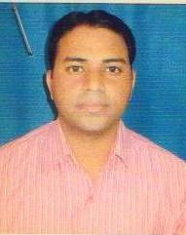 | Mr. Sunil Kumar  M.A. (Hindi), M.A. (Pol Sci ) , M.Ed. (G & C), UGC (Edu & Hindi) | Asst. Prof
4. | 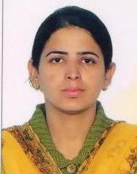 | Mrs. Swippendeep Kaur  M. Sc. (Zoology), M.Ed., M. Phil, UGC in Edu. | Asst. Prof
5. | 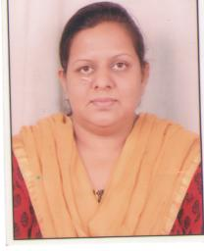 | Ms. Anisha Monga  M.A. (Eco.) , M.Ed., UGC in Edu.  PG Diploma in Statistics, Pursuing Ph. D | Asst. Prof
6. | 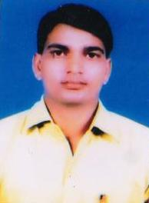 | Mr. Rajendar Prasad Bairwa  M. Phil (Edu), M. Ed, B. Ed, M. A. (Geo), B. A., UGC in Edu | Asst. Prof
7. | 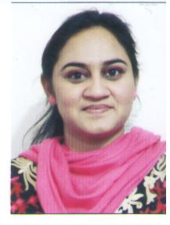 | Ms. Paramjit Kaur  M.A (Economices), M. Ed, NET in Edu. | Asst. Prof
8. | 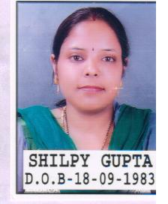 | Mrs. Shilpy Gupta  M. Sc (Maths), M. Ed, M.Phil (Edu), NET in Education, Pursuing Ph. D | Asst. Prof
9. | 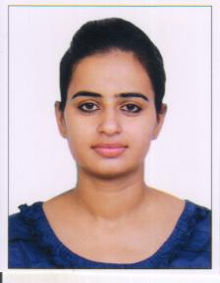 | Ms. Ritu Puri  M.A (English), M. Ed, NET in Edu. Pursuing Ph. D | Asst. Prof
10. | 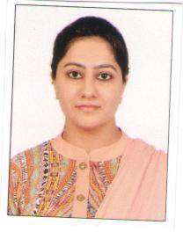 | Ms. Navreet Kaur  M.Sc. (Microbiology) M.Ed. UGC NET (Edu.) | Asst. Prof
11. | 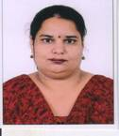 | Mrs. Avneet Bhushan  M.A.(History), B.Ed., M.Phill ,(History),M.A.(Edu) | Asst. Prof
12. | 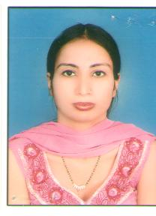 | Mrs.Priya Bedi  B.Sc, M.A. (Hindi) M.Ed. (UGC) Net, Pursuing Ph. D | Asst. Prof
13. | 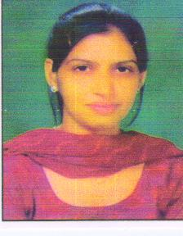 | Ms. Neeru  M.Com, M.A.(Eco.), M.Ed., PG Diploma in Statistics, (UGC) Net | Asst. Prof
14. | 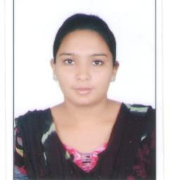 | Ms.Sumanpreet  M.A.(Punjabi) M.Ed., PGDCA, Net Edu. | Asst. Prof
15 | 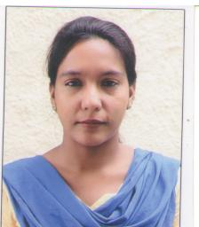 | Mrs.Amandeep Kaur  M.A.(Punjabi) M.E | Asst. Prof
16 | 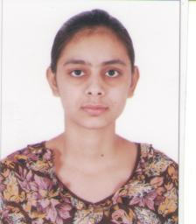 | Ms.Gagandeep Kaur  M.A.(English), M.Ed. | Asst. Prof
17 | 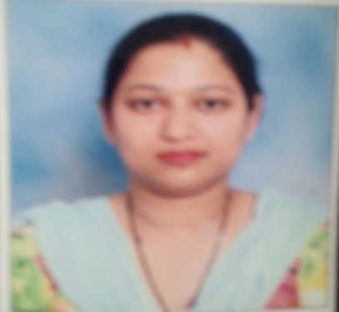 | Mrs. Deepali  M.Sc. (Math),B.Ed., M.Ed. | Asst. Prof
18 | 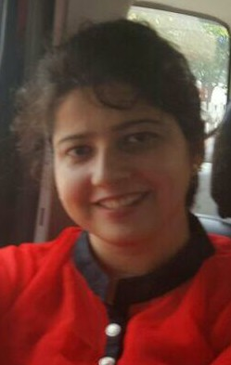 | Mrs.Divya Kaura  M.A.(Sociology), M.Ed. | Asst. Prof

19 | 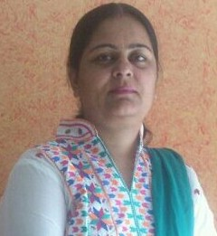 | Mrs.Jasinder Kaur  M.A.(History), M.Ed., M.Phil, | Asst. Prof
22 | 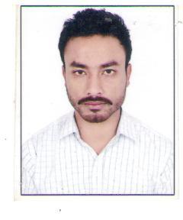 | Mr.Harvrinder Singh  M.P.Ed. | Asst. Prof
23 | 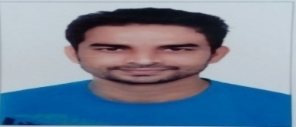 | Mr. Rajesh Kumar  B.A. (Music), M.A. (Theater) | Instructor
LIBRARY STAFF
1 | 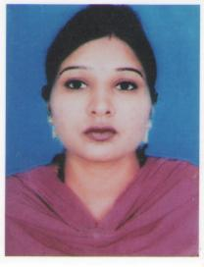 | Mrs.Babli Rani  B.Lib.,M.Lib, M.A., E.T.T. | Librarian
2 | 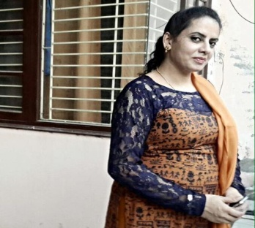 | Paramjeet Kaur  M.A.(Hindi) | Asstt.Librarian

ADMINISTRATIVE
OFFICE STAFF
1 | 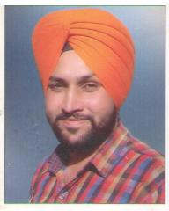 | Mr.Mehar Singh  B.A., PGDCA, MSc.IT, | Office Supdt.. Cum.Executive
2 | 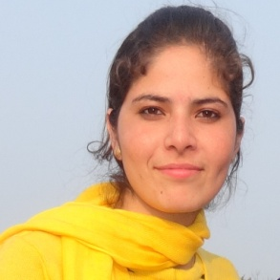 | Ms.Parwinder Kaur  B.A. DCA, Pursuing PGDCA | Clerk

